Plant Vogtle Units 3 & 4

Sixth Semi-Annual
Construction Monitoring Report

February 2012

Docket No. 29849

EXECUTIVE SUMMARY

This is the sixth semi-annual Vogtle Construction Monitoring (“VCM”) report (“Sixth VCM Report”) submitted by Georgia Power Company (“Georgia Power” or the “Company”) to the Georgia Public Service Commission (the “Commission”) pursuant to the stipulation (the “Stipulation”) adopted in the Commission’s order in Docket No. 27800 (the “Certification Order” or “Certification”) for the reporting period of July 1, 2011 through December 31, 2011 (the “Reporting Period”). The Company requests that the Commission verify and approve the construction expenditures for the Plant Vogtle Units 3 and 4 project (the “Project”) during the Reporting Period and this Sixth VCM Report provides the basis upon which the Commission may verify and approve such expenditures as made pursuant to the certificate in accordance with O.C.G.A. § 46-3A-7(b). The Company is not requesting any changes to the overall Project schedule or budget for this Reporting Period.

The highlights of this Sixth Reporting Period are as follows:

- The Project is on track and the targets are achievable. The Commercial Operation Date (“COD”) of Unit 3 is expected in 2016, and the COD of Unit 4 is expected to be in 2017.

- The Nuclear Regulatory Commission (“NRC”) approved the Westinghouse Electric Company LLC (“Westinghouse”) AP1000 Design Certification Document (“DCD”) Amendment, effective December 30, 2011. On February 10, 2012, the NRC issued the Combined Construction and Operating Licenses (“COLs”) for Plant Vogtle Units 3 and 4 (the “Units”), which allows full construction to commence. The issuance of the nation’s first COLs is a monumental step for Southern Company, Georgia Power, our partners, the nuclear industry and the state of Georgia. This milestone was made possible by the foresight shown by this Commission throughout the process that supported the early study of the Project as a generation resource option, certified the Project and approved the Engineering Procurement and Construction (“EPC”) Agreement structure, and allowed the inclusion of Construction Work In Progress (“CWIP”) in rate base.

- The NRC review has been rigorous and delivers the safety oversight and accountability that our public demands. This first-ever COL process was accomplished within six months of projections made at the outset more than five years ago.

- Our foremost focus, as we proceed with full construction, is on safety and quality. The overall construction schedule has not changed. The target to complete the units to serve customer needs in 2016 and 2017 can still be achieved. We will continue to review the costs and benefits of possibly compressing the construction schedule, but we will not compress the schedule to the extent doing so would adversely impact quality or safety.

- The Company is being accountable to customers, and is overseeing the Project to ensure that quality and safety are built into the plant. The Project continues to offer a less expensive generation option to customers than any other available alternative. Furthermore, the Company continues to believe that the Project will have a more favorable impact on customers than was projected at certification.

- The Company remains in the position to deliver more than $1 billion in customer benefits that were not assumed when the Project was originally certified. These benefits are primarily the result of the Company’s pursuit of the U.S. Department of Energy (“DOE”) loan guarantee (“Loan Guarantee”), the production tax credits (“PTCs”), and the Commission’s approvals necessary to include CWIP in rate base and to execute EPC Agreement Amendment 3.

During the Reporting Period, construction of Units 3 and 4 continued to track under the $6.113 billion certified amount (the “Revised Certified Amount”), and the Company continues to manage the pressure on both the Project schedule and cost. There will be increased costs to complete the Project. However, not all of those increased Project costs, if any, will be reflected in an increase to the Revised Certified Cost. The amount of those costs and the question of which party to the EPC Agreement bears what portion of those costs have not yet been settled between and among the parties to the EPC Agreement. The EPC Agreement provides that most of the cost of this Project is subject to that firm price contract, which has certain specified escalations and is otherwise increased by change orders that are allowed only if they meet certain pre-defined conditions in the EPC Agreement. There are three broad categories of possible cost increases resulting from submitted and potential change orders.

The first broad category of potential cost increases includes pending change orders that already have been submitted to the Company, Oglethorpe Power Corporation, Municipal Electric Authority of Georgia and the City of Dalton (the “Owners”) by Westinghouse and Stone & Webster, Inc. (together with Westinghouse, the “Consortium”). Some of those have been approved, some are under review and some have been denied and are disputed. This is typical of a project of this size and scope being built under this type of EPC Agreement. Through the Reporting Period, the costs associated with these approved change orders are reflected in the costs and budgets in this filing and are within the Revised Certified Amount.

The second broad category of potential cost increases includes certain design changes that the Consortium made during the DCD review process. Based upon the information that the Company currently has, the Company does not believe that these costs meet the pre-defined conditions in the EPC Agreement to make them the responsibility of the Company and its customers. These costs have not yet been reduced to a change order, and the Consortium has not yet specified the amount of those costs, but the Owners are nonetheless aware of the Consortium’s intent to seek recovery of these costs. The potential costs associated with these anticipated change orders are not reflected in the costs and budgets in this filing.

The third broad category of potential cost increases includes costs associated with the delays in the CODs. Based upon the information available to the Company at this time, the Company does not agree that it is responsible to the Consortium for the Consortium’s as-yet specified delay costs. The potential costs associated with schedule delays are not reflected in the costs and budgets in this filing.

The Company is currently engaged in discussions with the Consortium to seek agreement on which party bears responsibility under the terms of the EPC Agreement for what portion of the costs flowing from these three broad categories of changes. As of the date of this filing, the Company has not agreed that it has any responsibility to the Consortium for any of these unapproved costs and with regard to most, denies any liability at all. With regard to the cost impact on the Owners of potential schedule delay, the Company plans to seek liquidated damages from the Consortium to mitigate any such potential costs.

The Company is aware of the regulatory scrutiny that this Commission expects to have during these construction monitoring proceedings. As negotiations with the Consortium continue over the next several months, the Company expects to continue to keep the Construction Monitor and the Commission apprised of that progress, and then seek an amendment to the EPC Agreement and the Certificate, if necessary and appropriate. The possibility that the $6.113 billion Revised Certified Amount could change as the result of change orders is allowed by the EPC Agreement. When the Commission found the structure of EPC Agreement and its allocation of risks between the Consortium and Owners to be reasonable, and certified the budgeted cost at $6.113 billion, it did so with an understanding that the EPC Agreement allowed change orders for certain specified reasons, but without allowing a contingency to cover any change orders or other unexpected and unbudgeted costs. It is unique for a project of this magnitude not to have a contingency, but the Company supported the Commission determination that it was appropriate in this regulatory setting. Any additional costs, including change orders, over the Revised Certified Amount must be shown to be prudent and approved, rather than simply drawn down from a contingency fund as they would be in a more typical project.

During this Reporting Period, the Company continued to apply the necessary resources to carry out its responsibilities to this Commission and as the Licensee of the Plant to ensure that the Project is built with safety and quality throughout. As discussed in more detail in Item 9, some additional costs were incurred during the period that were not originally budgeted, but these costs have been offset by previously unallocated budget amounts. None of these costs were to perform tasks that were originally within the Consortium’s scope of work. They represent an expansion of the Owners’ scope of work beyond what was originally budgeted to perform these critical functions. These activities will result in savings to customers over the life of the Project.

The Company continues to conduct surveillance and closely monitor the Consortium’s improvement efforts for the quality and production issues with Shaw Modular Solutions (“SMS”). SMS has demonstrated progress in implementing an improvement plan following a deferred NRC inspection from January 2011. The Consortium conducted a mock NRC inspection in July 2011 to prepare for the NRC re-inspection that occurred November 14-18, 2011. The Company will have the opportunity to review and provide input regarding SMS’s action plans to address issues outlined in the NRC’s inspection report, which will be discussed in the next semi-annual VCM report.

The Company continues to pursue the PTCs for the Project. Negotiations of the Loan Guarantee terms and conditions were ongoing during the Reporting Period and the current expectation is that the closing should occur in the next reporting period. The Company will only enter into a Loan Guarantee Agreement with the DOE if such an agreement benefits customers. Current projections show that the savings expected to be earned by the PTCs, by the Loan Guarantee, by including CWIP in rate base and by execution of EPC Agreement Amendment 3, have the equivalent effect of reducing the total cost impact of the Project on customers by more than $1 billion. The Company believes that when the Project is completed, and all costs and other savings are considered, the Project will have a more favorable impact on customers than was projected at Certification.

The Commission staff (“Staff”) and the Construction Monitor have been kept abreast of the progress of construction, and the issues discussed above, as well as those discussed throughout this Sixth VCM Report, through monthly meetings with Georgia Power, and through their review of the Level 1 schedule and the Vogtle 3 and 4 Project Metrics Packages. While the Project continues to track under the Revised Certified Amount, as with any project of this magnitude, the cost of several individual items will be greater than budgeted while the cost of others will be less than budgeted. However, as stated above, when the overall net change of these items is considered, together with the impact of the costs savings of the Loan Guarantee, PTCs, EPC Agreement Amendment 3 and CWIP in rate base, the overall impact of the Project is more favorable for customers than originally anticipated at the time of Certification.

In conclusion, the Company is currently managing pressures on both the Project schedule and cost, and will continue to do both while expanding its oversight efforts. Currently, the Total Current Forecast is less than the Revised Certified Amount; therefore, the Company does not request an adjustment to the Revised Certified Amount at this time. The Company requests that the Commission verify and approve the construction expenditures incurred during the Sixth VCM Reporting Period.

As agreed in the Stipulation that was incorporated into the Certification Order, the Company responds to the 15 specified items in the order in which they appear in Section 2(d)(1-15) of the Stipulation as follows:

- The reasons for any additional change in the estimated costs of the units since the process began.

For purposes of this Reporting Period, the Company reports against a total Revised Certified Amount of $6.113 billion. The anticipated impact of the capital cost is less than it was projected to be at the time of Certification due to the beneficial impact of the Loan Guarantee and PTCs. The original $6.4 billion certified amount has already been reduced to $6.113 billion to reflect the Commission’s order to allow for the inclusion of CWIP in rate base. The current cost and forecast reports are provided in Tables 1.1 and 1.1a below.

The Company seeks to clarify that the cost of nuclear fuel yellowcake being purchased for the initial load is recorded in the nuclear fuel stock account and is excluded from rate base. However, the Company is accruing Allowance of Funds Used During Construction (“AFUDC”) consistent with the treatment ordered by Docket No. 3397, and the subsequent Federal Energy Regulation Commission (“FERC”) audit directions, that were issued during the construction of Vogtle Units 1 and 2. Additionally, because nuclear fuel yellowcake is not part of the Revised Certified Amount, the AFUDC is not being collected under the NCCR tariff.

Docket No. 3397, issued in 1983, provided that nuclear fuel purchased for units under construction could not be included in the rate base for recovery from ratepayers as the costs were not considered used or useful to the ratepayer in the immediate or near future. Rather, the Commission ordered the Company to treat the nuclear fuel (purchased for use at the plant being constructed) as CWIP, with the interest accrual being capitalized and included in the base rate when the fuel is ultimately used. During the same time frame, the FERC audited the Company and required the accrual of AFUDC on yellowcake inventory to be recorded as a deferred debit as opposed to being included in the nuclear fuel stock account. The deferred debit is then amortized directly to CWIP during the test period and to nuclear fuel expense after COD, respectively, as the fuel is burned.

Table 1.1
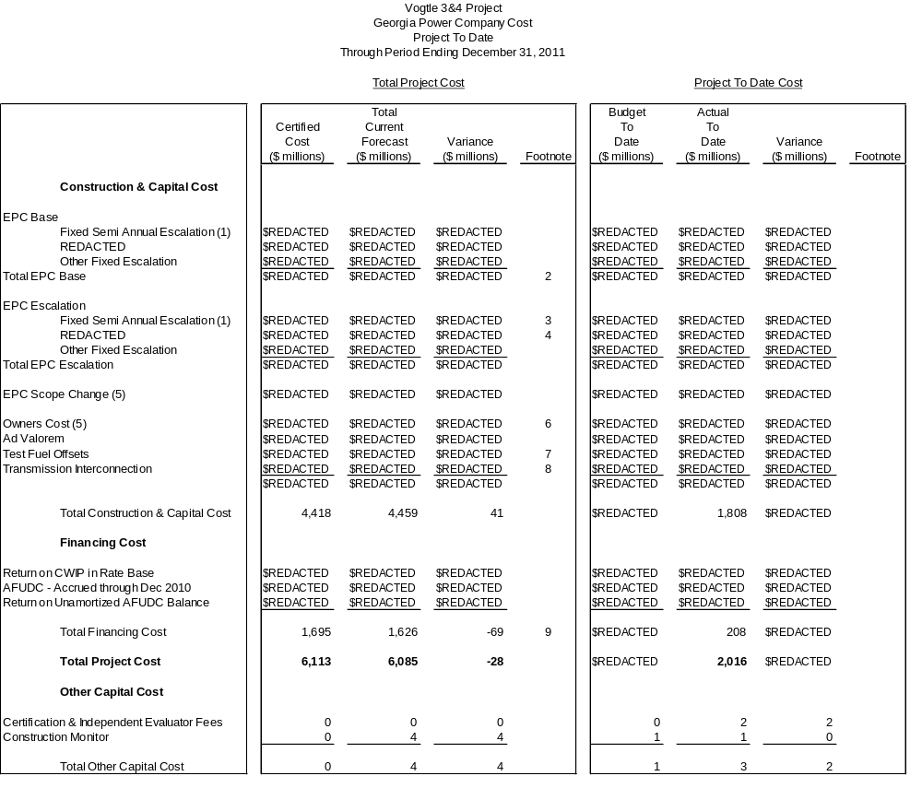

Summary of Customer Benefits since Certification ($ million)
Customer Benefits | DOE Loan Guarantee | PTCs  (50-100%) | Amendment No. 3 | CWIP  in Rate Base | Total
2016 Value | $REDACTED | $REDACTED | $REDACTED | $333 | >$1,100

Footnotes
- As a result of Amendment No. 3 to the EPC Agreement, the REDACTED (REDACTED) was replaced with Fixed Semi Annual Escalation.
- EPC Base reflects an increase of $REDACTED as a result of simulator budget transfer from Owners Costs, as described in the Second VCM Report.
- The Certified Cost reflects the REDACTED escalation rate estimated at REDACTED; current forecast reflects the Fixed Semi Annual Escalation provisions of Amendment No. 3 to the EPC Agreement.
- REDACTED Escalation current forecast revised based on actual to date and projected escalation rate REDACTED.
- EPC Scope Change amounts (Forecasted and Project To Date) were included in Owners Cost through the Fourth VCM Report. EPC Scope Change reflects an increase from the Fifth VCM Report of $REDACTED for Integrated Corrective Action Program as further described in Item 9.
- Owners Cost reflects an increase of $REDACTED, partially off-set by a decrease of $REDACTED for the transfer of the simulator budget to EPC Base, a decrease of $REDACTED for transmission items transferred to Transmission Interconnection, and a decrease of $REDACTED transferred to EPC Scope Change. Changes in Owners Cost since the Fifth VCM Report are further described in Item 9.
- Test Fuel Offsets reflects REDACTED REDACTED REDACTED REDACTED.
- Transmission Interconnection reflects an increase of $REDACTED, which is the current estimate for cost issues associated with additional transmission work, as described in the Second VCM Report.
- Financing cost was lowered primarily as a result of changes in the timing of cash expenditures.
Note: Details may not add to totals due to rounding.
Table 1.1a (Trend)
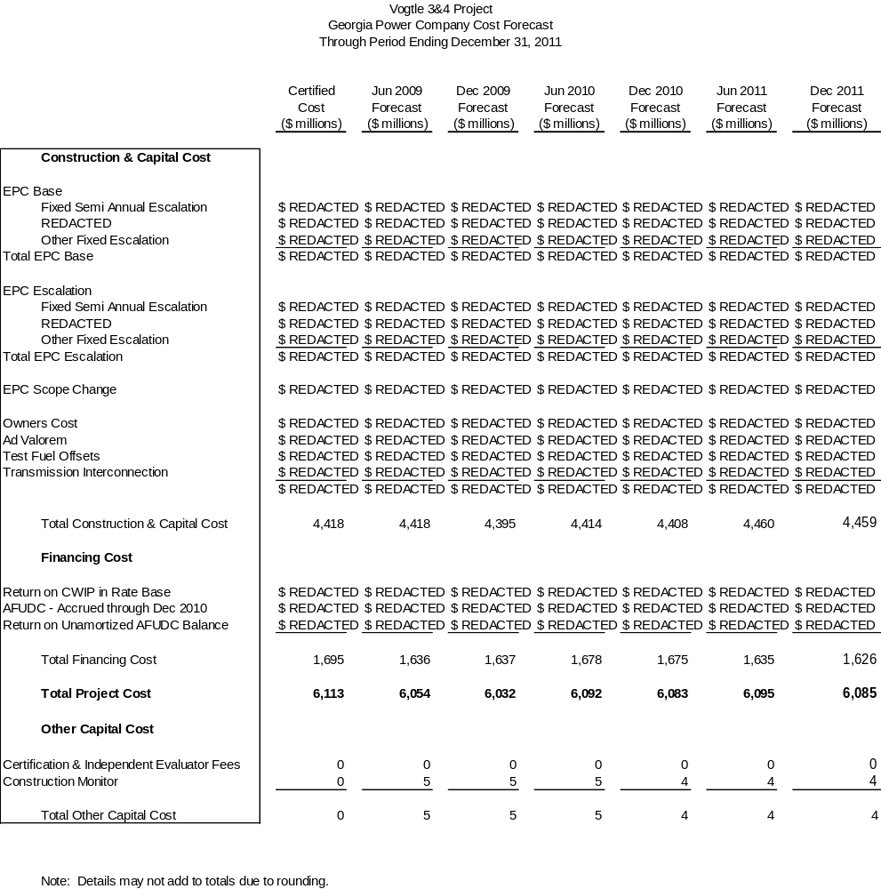

- A description of any cooperative actions between other builders of nuclear units in the southeast to address labor, crafts, engineering and management requirements.

Southern Nuclear (“SNC”) cooperates with other builders and potential builders of nuclear units to address engineering and management requirements via industry related groups. These groups provide forums for builders and potential builders of a given technology type to consider issues common to the participants, including development of training, procedures and programs. The groups operate under strict antitrust rules and do not collaborate in any way to influence the labor markets.

As reported in previous VCM reports, SNC is a member of NuStart and has been engaged with other NuStart members (DTE Energy, Duke Energy, EDF International North America, Inc., Entergy Nuclear, Exelon Corporation, Nextera Energy, Progress Energy, SCANA Corporation, and Tennessee Valley Authority) to support design finalization efforts and to provide licensing support to SNC as the Reference COL Applicant. The receipt of the COLs concludes the NuStart effort in support of AP1000 including Vogtle Units 3 and 4 since the group has successfully met its objective through the design certification and licensing process. Going forward, any Reference COL activities will be coordinated through APOG LLC (“APOG”).

SNC is a member of APOG and has engaged with other APOG members (Progress Energy Carolinas, Duke Energy Carolinas, Florida Power & Light and South Carolina Electric and Gas Company (“SCE&G”)) to support the activities listed below, either through financial means or with participation:

- Development of a knowledge and abilities (K&A) catalog, which was submitted to the NRC on behalf of the industry, and provides the basis for the NRC licensed operator training and examinations throughout the life of the plant. The NRC issued the catalog to the industry on November 4, 2011.
- Review of Westinghouse procedures and development of a standard set of operation and maintenance procedures that will be proposed to all AP1000 utilities.
- Review of engineering and design issues with Westinghouse to resolve common problems for the benefit of all AP1000 owners.
- Review of the final layout of the plant to ensure it meets regulatory requirements and industry expectations for constructability, operability, maintainability, inspectability and testability.
- Review of plant design changes proposed by the Consortium to ensure the proposed changes are consistent with the plant design basis and licensing basis requirements.
- Development, together with APOG member utilities, Westinghouse and the NRC, of human factors programs associated with man machine interface and procedure usage protocols. The computerized procedure system presents some opportunities to rethink traditional methods that could simplify communications, reduce potential human errors and enhance safe operations.
- Coordination of the development of programs, training material and procedures necessary for testing, start-up and operation of the AP1000. The APOG Project Manager coordinates the development of various programs, such as engineering, maintenance, chemistry, health physics, operations and Occupational Safety and Health Administration compliance each as they relate to the AP1000. The APOG Project Manager also interacts with Westinghouse on behalf of APOG in the development of standard training materials and procedures.
- Support for standard aspects of licensing and licensing compliance.
- Coordination of, through the APOG Quality Assurance Committee, QA surveillance activities of major vendors and sub-tier suppliers. In addition, the APOG QA Committee members, along with Westinghouse and Shaw Quality Assurance management, participate in quarterly meetings to assure the independent quality organizations in each of the companies are aligned.

SNC, in cooperation with SCE&G, has contracted with Westinghouse for initial training program development, instruction, and certification of utility licensed operator instructors. The first class of 11 SNC instructors has been certified by Westinghouse through 15 weeks of training at Westinghouse facilities on the AP1000 control room simulator, and the second class consisting of 13 operations instructor candidates commenced on January 9, 2012. Once the second class concludes, certification of the initial complement of SNC instructors to teach licensed operator candidates will be completed.

As reflected in previous reports, SNC and SCE&G continue working cooperatively to implement a standard approach for meeting new cyber security requirements that apply to the AP1000 as defined in Regulatory Guide 5.71, “Cyber Security for Programs for Nuclear Facilities.”

SNC continues to participate in leadership roles for various Nuclear Energy Institute (“NEI”) sponsored groups, specifically, the Design Centered Working Group (“DCWG”), the New Plant Working Group (“NPWG”) and the New Plant Oversight Committee (“NPOC”). The DCWG, formed by NEI at the request of the NRC, is made up of the AP1000 utilities for the purpose of standardizing licensing activities associated with the DCD, the COL and construction of the AP1000. The NPWG, managed by NEI, is a policy-making group that establishes guidance for addressing the NRC, legislative and public affair issues for new reactors (e.g. AP1000, ESBWR) and modular reactors. The direction for the NPWG is established by the NPOC, which is made up of nuclear industry executives.

The Company’s resident Shanghai project manager focuses on maintaining and strengthening relationships with the owner companies and the operating companies of the four AP1000 units currently under construction at Sanmen Nuclear Power Station and Haiyang Nuclear Power Plant. The construction efforts at all four Chinese units are approximately 24 months ahead of the Vogtle Project and, therefore, are sources of lessons learned for the Units’ construction and subsequent operation. The Shanghai project manager routinely travels between the two China sites to monitor progress against a published milestone schedule to pinpoint opportunities for construction observations. During the Reporting Period, efforts of the Shanghai project manager were incorporated into the development of construction monitoring plans for major Vogtle Units 3 and 4 activities. The Shanghai project manager communicated construction-related questions to the Chinese construction teams and was able to provide meaningful information used to develop SNC construction monitoring plans. At Sanmen, he visited the site to discuss lessons learned during the setting of the unit 1 reactor vessel and relayed useful information associated with removing the reactor vessel support during the lift. He also serves as the point of contact for discussions on First of a Kind (FOAK) and First Three of a Kind (F3OAK) testing at both Sanmen and Haiyang.

- An explanation of how the indices used in the EPC contract are tracking.

On February 22, 2010, the Consortium and Georgia Power, acting for itself and as agent for the Owners entered into Amendment No. 3 to the EPC Agreement. Amendment No. 3, which was approved by the Commission on August 17, 2010, replaces certain index-based adjustments to the purchase price with fixed escalation amounts. This means commodity and inflation risks have been significantly reduced, and the risk of higher than anticipated escalation is shifted from the Company’s customers to the Consortium.

With Amendment No. 3 in place, the only remaining index is the REDACTED Index, which is currently tracking REDACTED original estimates on a cumulative basis, as shown in Table 3.1. The original certified budget included a forecast for REDACTED based on REDACTED annual escalation. To date, REDACTED rates have experienced a REDACTED annual escalation rate. Combining the REDACTED to date with a forecast for future REDACTED rates based on July 2010 actual values escalated at REDACTED, the Project forecasts REDACTED REDACTED.

Table 3.1

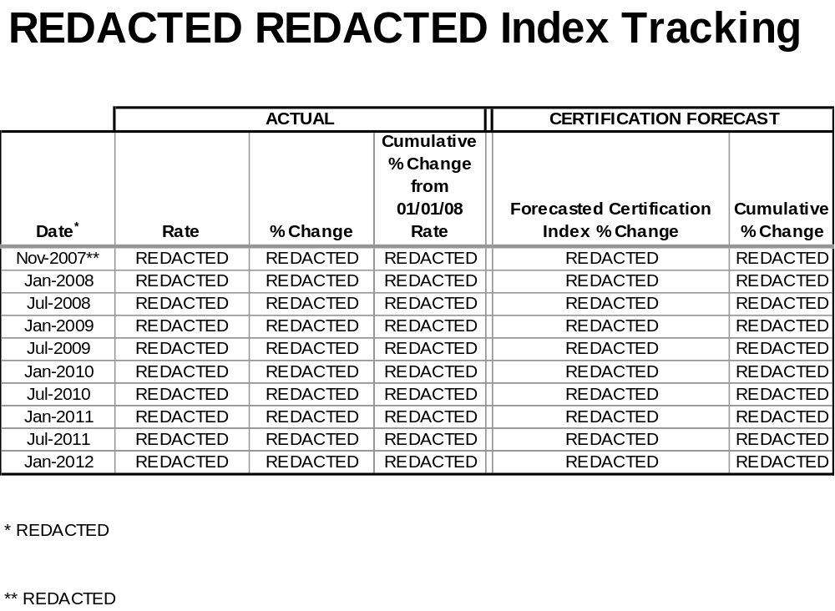

- Any updated estimate of onsite spent fuel storage costs, including the costs for dry storage of spent fuel for an extended period of time after shutdown, and any updated calculation of spent fuel storage costs assuming Yucca Mountain is never available.

As previously reported, the Company provided a sensitivity analysis for spent fuel storage costs to the Staff and the Independent Evaluator in October 2008 that estimated the cost of on-site storage through 2088, which is ten years beyond the anticipated shutdown of Unit 4. There is no change at this time to the estimate provided in October 2008. In November 2008, SNC executed a contract with the DOE that requires the DOE to complete removal of spent fuel from the Units within ten years from the date of the shutdown of Unit 4.

As discussed in the Fifth VCM Report, the U.S. Secretary of Energy established a 15 member “Blue Ribbon Commission on America’s Nuclear Future” (“BRC”) and charged it with addressing long-term storage and disposal options for spent nuclear fuel. The three BRC subcommittees issued draft reports in late spring 2011 to recommend policy and legislative changes to address alternative storage options, spent fuel recycling and disposal options. Those reports have been the subject of regional public meetings and public comment in September and October 2011. The BRC held a public hearing in Washington D.C. on December 2, 2011 to consider and discuss the subcommittee reports.

The BRC concluded its assigned task when it submitted its report to the Secretary of Energy on January 26, 2012. Although outside the Reporting Period, the final report concludes the tasks of the BRC, which recommended a nuclear waste management strategy with eight key elements:
- a new, consent-based approach to siting future nuclear waste managing facilities;
- a new organization dedicated solely to implementing the waste management program and empowered with the authority and resources to succeed;
- access to the funds nuclear utility ratepayers are providing for the purpose of nuclear waste management;
- prompt efforts to develop one or more geologic disposal facilities;
- prompt efforts to develop one or more consolidated storage facilities;
- prompt efforts to prepare for the eventual large-scale transport of spent nuclear fuel and high-level waste to consolidated storage and disposal facilities;
- support for continued U.S. innovation in nuclear energy technology and for workforce development;
- active U.S. leadership in international efforts to address safety, waste management, non-proliferation, and security concerns.

Until any recommendations are implemented, there is no change in the expected spent fuel storage costs.

- The status of the Company’s loan guarantee application at the Department of Energy and to the extent that application is granted, then the Company shall also report on the impact it has or would have on the final expected in-service cost of the units.

There has been no change in the status of the Company’s conditional commitment for a Loan Guarantee from the DOE that would apply to future Company borrowings related to the Units since the last reporting period. Total guaranteed borrowings will not exceed 70 percent of eligible Project costs, or approximately $3.4 billion.

The receipt of the COLs from the NRC on February 10, 2012 allowed activities to continue in support of the final approval and issuance of the Loan Guarantee. The Company remains engaged with the DOE in negotiation of definitive agreements, completion of due diligence by the DOE, and receipt of any necessary regulatory approvals or conditions as defined in the definitive agreements. The Company expects that these activities will conclude during the next reporting period.

As a result of the Loan Guarantee, Georgia Power and its customers are currently expected to save approximately $15 million to $20 million in interest costs annually, at the corporate level, over the expected life of the bonds. The actual amount of the interest savings will depend on the final terms and the timing of the specific borrowings. The Company will only enter into a Loan Guarantee Agreement with the DOE if such an agreement benefits customers.

The estimated impact of the DOE Loan Guarantee on this Project is reflected in financing costs in Tables 1.1, 1.1a, and 8.1. The portion of the estimated net benefits of the Loan Guarantee that is allocated to the Project has been reflected in the Total Current Forecast based on the information available at this time. Discussion with the DOE on this topic is ongoing. Additional costs associated with compliance with applicable federal regulations pertaining to the acceptance of a Loan Guarantee may be identified and incorporated at a later date.

- Whether the Company is using trust preferred financing and the impact it has or would have on the expected in-service cost of the units.

In September 2011, the Company redeemed all remaining outstanding trust preferred securities to continue minimizing overall financing costs for customers.

- The extent to which the Company is using short term debt and the impact it has or would have on the expected in-service cost of the units.

There has been no change in the status of this item since the last reporting period.

- An update of the estimated in-service cost and projected date of commercial operation of both units.

An update of the estimated in-service cost of both Units is shown in Table 8.1 below. The Company has not proposed any revision to the Project budget at this time, but is currently managing cost pressures and risk and will continue to monitor issues associated with design finalization, fabrication and construction milestones. The Commission has made it possible for the Company to be in a position to deliver to customers more than $1 billion in benefits from the DOE Loan Guarantee, PTCs, inclusion of CWIP in rate base and execution of Amendment No. 3.

During the Reporting Period, the Integrated Project Schedule was updated to reflect a better estimate for the COL issuance date resulting from the delayed DCD Amendment approval. The Consortium removed any compression from the Integrated Project Schedule to help facilitate an effective assessment of the impacts of delays associated with licensing approvals and module fabrication. The Consortium’s Level 1 Schedule of December 30, 2011 forecasts a Unit 3 COD of November 28, 2016 and Unit 4 COD of November 28, 2017.

The overall construction schedule has not changed. The target to complete the Units to serve customer needs in 2016 and 2017 can still be achieved. The Company will continue to review the costs and benefits of possibly compressing the construction schedule, but will not compress the schedule to the extent doing so would adversely impact quality or safety.

Table 8.1

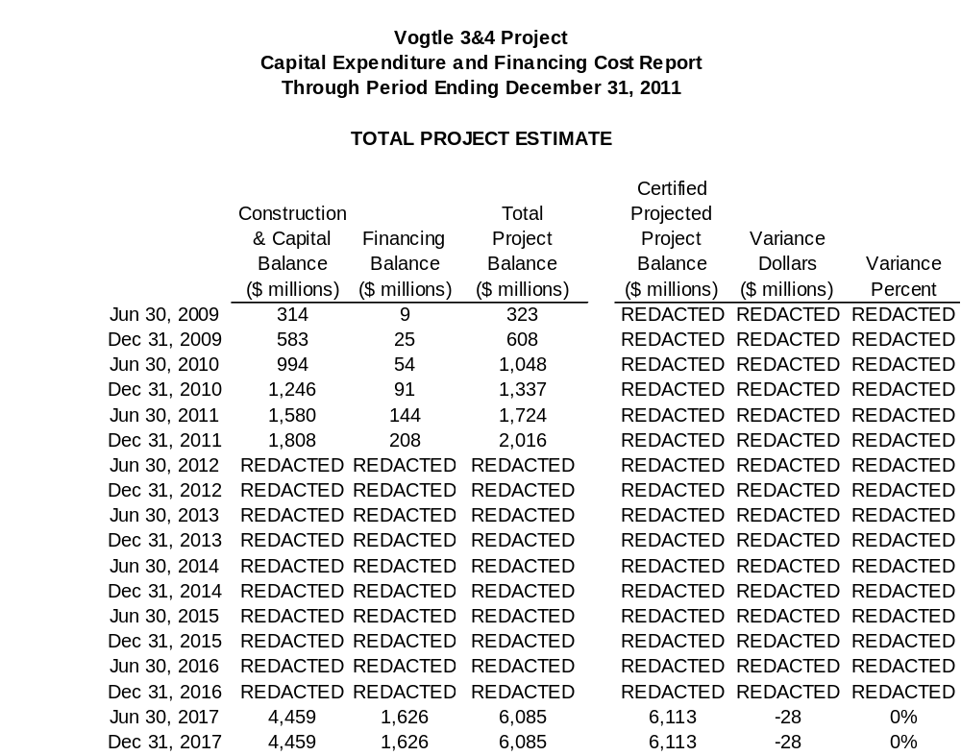

- A description of all major sources of changes (both increases and decreases) to the in-service cost and sources of change in commercial operation dates, if any.

The current forecasted Total Construction and Capital Cost for the Units is $4.459 billion and the current forecasted Total Financing Cost is $1.626 billion, for a current forecasted Total Project Cost that is now projected to be $6.085 billion, which is $28 million below the Revised Certified Amount of $6.113 billion.

Table 1.1 reflects all significant sources of changes in the in-service cost since Certification. The major source of projected cost decreases results from the Commission’s adoption of Amendment No. 3 to the EPC Agreement. While these savings have been offset by potential new and emerging issues as described in previous VCM reports, Table 9.1 below reflects additional projected costs identified during this Reporting Period.

Table 9.1
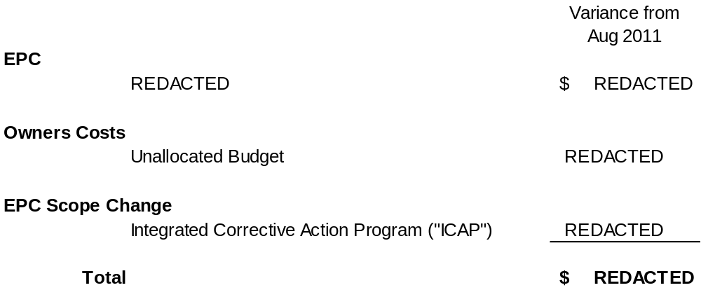

The cost estimates provided in Table 9.1 are based upon the best information available at this time. The Company will continue to closely monitor these issues and revise estimates as necessary in future reporting periods. Below is a more detailed description of the major sources of change during this Reporting Period.

EPC – REDACTED REDACTED REDACTED REDACTED REDACTED REDACTED REDACTED REDACTED REDACTED REDACTED REDACTED REDACTED REDACTED.

Owners Cost - Unallocated Budget: There was a small portion of the Owner's Cost forecast that was not allocated at the time of Certification, which is now being utilized to manage emerging cost pressures, including the cost increase in EPC Scope Change as described below.

EPC Scope Change – Integrated Corrective Action Program (“ICAP”): An estimated cost increase is reflected for additional costs incurred by the Consortium for the development and implementation of an ICAP. In order to meet NRC and industry expectations for problem identification and resolution, the ICAP has been developed to integrate the corrective action programs of SNC, Shaw and Westinghouse. The three programs individually comply with 10 CFR Part 50 Appendix B requirements for corrective action programs and are now linked through integrated screening, management review and corrective action review board meetings. Implementation of the ICAP better assures conditions adverse to quality are promptly documented, reviewed for significance, investigated, and dispositioned collaboratively across the entire Project team in a timely and effective manner. Furthermore, the ICAP utilizes the SNC Condition Reporting System as the corrective action system to track and trend all conditions potentially adverse to quality on the Project associated with processes, programs, materials and components.

The Company is not requesting a change in the CODs as approved in the Certification Order at this time. The Consortium’s Level 1 Schedule at the end of this Reporting Period forecasts the Unit 3 and 4 CODs in November 28, 2016 and November 28, 2017, respectively. The target to complete the Units to serve customer needs in 2016 and 2017 can still be achieved. The Company will continue to review the costs and benefits of possibly compressing the construction schedule while keeping the foremost focus on quality and safety of construction.

- The status of the Company’s combined construction and operating license (COL) applications at the Nuclear Regulatory Commission.

Although outside the Reporting Period, the NRC issued the COLs on February 10, 2012.

During the Reporting Period, collaborative efforts of the Company, Westinghouse, and the NRC Staff contributed to this result. As previously reported in the Fifth VCM Report, the Final Safety Evaluation Report (“FSER”) on DCD Revision 19 was issued by the NRC on August 5, 2011. The NRC Staff completed its review of DCD Revision 19 and issued SECY 11-0145 to the NRC on October 18, 2011 recommending affirmation of the AP1000 DCD Amendment. On December 22, 2011, the NRC announced its vote to approve the rule to certify the amended AP1000 reactor design and subsequently published the rule in the Federal Register on December 30, 2011, making it immediately effective.

The NRC Staff also completed all review activities of the COL applications during the Reporting Period. On August 5, 2011 the NRC issued the COL FSER subsequently issued SECY 11-110 on August 9, 3011 that began the NRC 120-day mandatory hearing process. The hearing was held on September 27 and 28, 2011 during which the NRC Staff endorsed the NRC’s issuance of the COLs. The COLs were subsequently affirmed on February 9, 2012 and issued on February 10, 2012.

In 2011, two petitions were filed requesting action on the Vogtle 3 and 4 dockets. As of December 31, 2011, the petitions had been denied and only one appeal remains open with the NRC. The Atomic Safety and Licensing Board (“ASLB”) rejection of the petition filed in August 2010 concerning the inspection programs and coatings for the containment vessel was affirmed by the NRC on September 27, 2011.

On September 9, 2011, the NRC denied a petition, filed on April 14, 2011, regarding the Fukushima event that requested the NRC suspend all licensing proceedings and the AP1000 design certification. The NRC’s ruling concurred with the positions taken by the NRC staff, NEI and SNC.

On August 11, 2011, petitioners filed a motion to reopen the record and proposed a new contention, which alleged that the Fukushima event constituted “new and significant” information in the closed Vogtle COL proceeding, and requires a supplemental environmental impact statement under the National Environmental Policy Act. On October 18, 2011, the ASLB denied the motion to reopen the record to consider this contention. Petitioners requested that the ASLB reconsider its October 18, 2011 order and reinstate the Fukushima-based environmental contention and appealed the ASLB’s October 18, 2011 order to the NRC. On November 30, 2011, the ASLB denied the petitioners’ motion to reinstate the contention. The petitioners’ appeal to the NRC is pending.

Table 10.1
Licensing - Vogtle 3 & 4 COLA Schedule

SNC starts Application development | June 1, 2006 (A)
SNC submits Application | March 31, 2008 (A)
NRC completes sufficiency review | May 30, 2008 (A)
Requests for information with the Staff | July 2008 - January 14, 2009 (A)
NRC conducts public meeting of overall submittal | July 17, 2008 (A)
NRC notices availability and opportunity for intervention | September 16, 2008 (A)
NRC issues draft environmental impact statement | August 26, 2010 (A)
NRC conducts public environmental meeting | October 7, 2010 (A)
NRC issues last advance Safety Evaluation Report (SER) material | December 2, 2010 (A)
ACRS completes review on SER material | December 17, 2010 (A)
NRC issues Final Environmental Impact Statement (FEIS) | March 18, 2011 (A)
SNC issues COLA rev 5 to tie to DCD Rev 19 | June 24, 2011 (A)
NRC Staff issues COL FSER | August 5, 2011 (A)
NRC Staff issues COL SECY | August 9, 2011 (A)
NRC COL Hearing | September 27-28, 2011 (A)
NRC affirms AP1000 DCD | December 22, 2011 (A)
NRC publishes DCD in Federal Register | December 30, 2011 (A)
NRC issues LWA-B | February 10, 2012 (A)
NRC issues Vogtle COLs | February 10, 2012 (A)

(A) - Actual

- The status of all other significant permits and licenses required from other governmental agencies.

Table 11.1

Permit | Activity Covered | Permitting Agency | Jurisdiction | Estimated Application Date | Projected Received Date | Required Date | Responsibility | Notes
Early Site Permit (ESP) and Limited Work Authorization (LWA) | ESP -Site approval for nuclear plant construction; LWA - approval for limited safety-related work | NRC | Federal | Actual August 2006 | Actual August 26, 2009 | September 2011 | SNC
Combined Operating Licenses (COLs) | Safety related construction for a nuclear power facility | NRC | Federal | Actual March 31, 2008 | Actual February 10, 2012 | N/A | SNC
Limited Work Authorization (LWA-B) | Approval for nuclear island rebar and embeds and placement of NI base slab | NRC | Federal | Actual October 2, 2009 | Actual February 10, 2012 | N/A | SNC
Section 404 Permit | Disturbance of crossing wetland areas or navigable waters | USACE | Federal | Actual  November 9, 2009  Revised January 7, 2010 | Actual  September 30, 2010 | October 2010 | SNC | 1,7,8, 16
Section 10 Permit | New intake/discharge to Savannah River | USACE | Federal | Actual  November 9, 2009 Revised January 7, 2010 | Actual  September 30, 2010 | October 2010 | SNC | 1,7,8, 16
Section 401 Certification | Compliance with water quality standards | GDNR | State | Actual  November 9, 2009 Revised January 7, 2010 | Actual  June 1, 2010 | July 2010 | SNC | 7,8,16
State Waters Buffer Variance | Land disturbing activities within 25’ state waters buffer | GDNR | State | Actual  January 8, 2010 | Actual April 29, 2010 | July 2010 | SNC
Certificate of Registration | Transportation of Hazardous Material | USDOT | Federal | Actual May 2009 | Actual May 14, 2009 | June 2009 | SNC
Federal Depredation Permit | Adverse impacts on protected species and/or their nests. For site and rail corridor upgrade. | USFWS | Federal | If needed | TBD | TBD | SNC/GPC | 13
Scientific Collecting Permit | Collection of specimens | USFWS | Federal | If needed | TBD | TBD | SNC/GPC | 13
Salvage Permit | Donation or receipt of protected species (bodies, feathers, etc.) for exhibit or scientific study | USFWS | Federal | If needed | TBD | TBD | SNC/GPC | 13
Objects Affecting Navigable Airspace -  Construction Notice | Notice of erection of structures (>200’ high) potentially impacting air navigation | FAA | Federal | Actual January 24, 2011 | Actual August 30, 2011 | September 2011 | Shaw | 17
Stand-Alone Construction Projects Storm Water Permit | Discharge storm water from site during construction | GDNR | State | Actual October 2008 | ongoing | Various | SNC
National Historic Preservation Act | Consultation regarding potential to adversely affect historic resources | GDNR | State | Actual letter to SHPO transmitting MOU for signature December 2009 | Actual January 20, 2010 | June 2010 | SNC | 17
Air Quality Construction Permit | Construction air emission sources | GDNR | State | Actual March 13, 2009 | Actual June 18, 2009 | June 2009 | Shaw | 10
NPDES Wastewater Permit | Regulates limits of pollutants in liquid discharge to surface water | GDNR | State | Actual September 23, 2009 | Actual April 16, 2010 | July 2010 | SNC | 2,7,17
Air Quality Construction Permit | Construction of plant air emission sources | GDNR | State | Actual May 22, 2009 | Actual April 9, 2010 | May 2010 | SNC | 17
GA Endangered Wildlife Act | Adverse impacts on state designated protected species and/or their habitat. For site and rail corridor | GDNR | State | If needed | TBD | TBD | SNC | 13
NPDES Wastewater Permit | Regulates limits of pollutants in liquid discharge to surface water | GDNR | State | Actual July 29, 2011 | REDACTED | REDACTED | SNC
NPDES Wastewater Permit | Regulates limits of pollutants in liquid discharge to surface water | GDNR | State | Actual July 29, 2011 | REDACTED | REDACTED | SNC
Infrastructure Projects Construction Storm Water Permit | Discharge storm water from linear construction sites (e.g. Roadways, transmission line and rail corridor) | GDNR | State | REDACTED | REDACTED | REDACTED | GPC
General Permit for Industrial Storm Water Discharges | Discharge storm water associated with industrial activity | GDNR | State | REDACTED | REDACTED | REDACTED | SNC | 4, 18
Permit to Operate a Public Water System | Operate a public, non-transient, non-community water system | GDNR | State | Actual June 16, 2009 | Actual July 14, 2010 | August 2011 | SNC
Permit to Operate a Public water System | Operate a public, non-transient, non-community water system | GDNR | State | Actual September 9, 2009 | N/A | N/A | SNC | 21
Permit to Withdraw Groundwater – Make up Wells 3 and 4 | Consumptive use of 100,000 gallons per day or more of groundwater | GDNR | State | Actual May 26, 2009 | Actual July 30, 2009 | November 2009 | SNC | 4
Permit to Withdraw Groundwater – Dewatering Activities | Dewater for foundation if needed for more than 60 days | GDNR | State | Actual  September 3, 2008 | Actual March 27, 2009 | June 2009 | SNC
Certificate of Abandoned Well(s) – MU-2A | Abandoned wells have been filled, plugged and sealed (notification required 30 days after well is abandoned) | GDNR | State | N/A | N/A | N/A | SNC | 11
Certificate of Abandoned Well(s) – SW-5 | Abandoned wells have been filled, plugged and sealed (notification required 30 days after well is abandoned) | GDNR | State | Actual February 18, 2009 Notification only | N/A – No response required | N/A | SNC
Permit to Withdraw Surface Water | Surface water withdrawal | GDNR | State | Actual July 29, 2011 | REDACTED | REDACTED | SNC
Land Disturbing Activity Permit | Permission to conduct land disturbing activities of one acre or larger, or within 25’ of any state waters | GDNR | State | N/A | N/A | N/A |  | 5
Private Industrial Landfill Permit | On-site disposal of solid waste consisting of construction and demolition debris | GDNR | State | Actual December 2008 | Actual Revised D & O Plan Received April 30, 2009 | May 2010 | SNC | 4
Solid Waste Handling Permit | Disposal of industrial solid wastes. Transportation of putrescible waste for disposal in a permitted landfill | GDNR | State | N/A | N/A | N/A | SNC | 6
Title V Operating Permit | Operation of air emission sources | GDNR | State | Actual May 22, 2009 | Actual June 11, 2010 | 2015 | SNC | 4
Certificate of Public Convenience and Necessity | Present and future public convenience and necessity requiring the operation of such equipment or facility | GA PSC | State | Actual August 1, 2008 | Actual March 17, 2009 Approved by PSC | March 17, 2009 | GPC
General Permit to Transport Radioactive Materials | Transportation of radioactive materials in the State of Georgia | GDNR/  GDPS | State | REDACTED | REDACTED | REDACTED | SNC | 4, 14
Utility Right-of-Way Permit | Utility right-of-way easement | GDOT | State | TBD | REDACTED | REDACTED | GPC | 14
Tennessee Radioactive Waste License-for-Delivery | Transportation of radioactive materials into the State of Tennessee | TDEC | State | REDACTED | REDACTED | REDACTED | SNC | 4
Utah Radiation Control Rule | Transportation of radioactive materials into the State of Utah | UDEQ | State | REDACTED | REDACTED | REDACTED | SNC | 4
Scientific Collecting Permit | State permit for collection of specimens | SCDNR | State | If needed | TBD | TBD | SNC/GPC | 13
Scientific Collecting Permit | State permit for collection of specimens | GDNR | State | If needed | TBD | TBD | SNC/GPC | 13
Land Disturbing Activity Permit | All land disturbing activities within the boundaries of Burke County | Burke County | County | N/A | N/A | N/A | N/A | 5
Building Permit | Construction, alteration, repair, or demolition of any building or structure within the boundaries of Burke County | Burke County | County | N/A | N/A | N/A | N/A | 5
Demolition Notification | Notice of demolition of buildings or structures | GDNR/  Burke County | State/  County | Various – first notification submitted in October 2008 | Various | Various | SNC
Land Disturbing Activity Permit | All land disturbing activities within the boundaries for transmission construction | Various | County | N/A | N/A | N/A | N/A | 5

Notes on Variances
1 | Permit application to be submitted in accordance with USACE regulations. Corps Master permit to cover intake and discharge
2 | If needed for Batch Plant
3 | Modification to existing permit – one for Unit 3 and one for Unit 4
4 | Modification to existing permit
5 | Not applicable since GPC is exempt pursuant to O.C.G.A 12-7-17 (10)
6 | Existing Permit – no modification required
7 | Final design info received from Shaw
8 | All items related to Corps Master permit
9 | MOU for SHPO temporarily delayed pending evaluation of Shaw inquiry on potential for relocation of intake structure
10 | Shaw Air SIP permit for construction issued June 18, 2009 by Georgia EPD; modification of permit was required due to changes in equipment needs and specifications by Shaw. Permit modification received December 29, 2009.
11 | Well MU2A will not be abandoned as originally scheduled and will be used temporarily to support construction water needs.
12 | Fire training Center (FTC) Potable Water permit application filed in September 2009 after need identified for potable water at FTC building.
13 | These permits will only be obtained if needed for the project. Permit application will be made once the need is identified and the use of TBD indicates that the permit application date will be determined consistent with the time the need is identified.
14 | TBD indicates that the State of Georgia has not indicated when these permit applications should be submitted. These permit application dates will be added as the project progresses based on input from the State of Georgia.
15 | Potable water permits issuance is based on completion of well installation and source water analysis. Working with Shaw to revise well completion schedule.
16 | These permits were resubmitted due to a Shaw calculation revision applied to the previous applications.
17 | The required date has been revised to reflect the associated construction need dates or project completion dates.
18 | Notice of Intent (NOI) submitted under a general permit one week prior to commencement of discharge.
19 | Source water sample results indicate the need to install additional potable water treatment. The necessary treatment system is currently under design and development. The facility can be occupied upon release of the building by Shaw; however the water cannot be used as a source of drinking water until the treatment system is added. The system can be used for sanitary purposes such as toilets and hand washing.
20 | A decision was made in September 2011 to tie the Fire Training Center (“FTC”) to the existing potable water system. Construction of this tie-in began in September and expected to be complete by the end of March 2012. The potable water permit application for the FTC will be withdrawn upon completion of the tie-in.

Note: Grayed variance notes are resolved, or are associated with permits that have already been received.

- The status of procurement, engineering, fabrication, transportation and erection of major equipment.

Consortium Responsibilities: There is no change in Consortium responsibilities since the Fifth VCM Report. Under the EPC Agreement, the Consortium has the responsibility for all activities involving the procurement, engineering, fabrication, transportation and erection of major equipment. Georgia Power, through its agent SNC, is overseeing those activities to confirm that the Consortium is abiding by the terms of the EPC Agreement and that the Project meets the standards of quality demanded by Georgia Power.

Procurement: The December 2011 EPC Monthly Status Report and December 2011 Vogtle 3 and 4 Project Metrics Package provide more detailed information regarding the status of procurement. In summary, according to the December 2011 EPC Monthly Status Report, Westinghouse and Shaw have issued 300 purchase orders (“POs”) as compared to the 332 POs that were planned. In addition to the information presented by the Consortium, the Company also tracks planned versus actual procurement activities for major components through its Vendor Surveillance Organization. All of the planned major components POs have been issued for the Project, except for the POs REDACTED REDACTED that are scheduled for release in the first half of 2012.

Engineering: The December 2011 EPC Monthly Status Report and December 2011 Vogtle 3 and 4 Project Metrics Package provide more detailed information regarding the status of engineering. In October 2011, the engineering design package delivery plan was revised to reflect an October 17, 2011 start on rebar installation. As of December 31, 2011, REDACTED of the REDACTED packages scheduled for issuance had been issued plus REDACTED packages that were due in later months. The REDACTED is expected to be issued by May 2012 and is not expected to impact the overall construction schedule. REDACTED REDACTED for issuance of associated Certified For Construction (“CFC”) packages. The Company continues to closely monitor progress of CFC package issuance on a weekly basis. The Consortium reports that the CFC package issuance fully supports Shaw procurement and construction needs.

REDACTED REDACTED continue to pose a risk for impact to the operator training schedule. The Company completed an assessment of the processes for I&C hardware and software design development and has recommended changes for those processes related to forecasts of total work scope and incorporation of design changes.

In the Fifth VCM Report, the Company reported on the commencement and subsequent suspension of the endurance test (final test) for the first China reactor coolant pump (“RCP”) prototype. During the Reporting Period, modifications were made to the motor stator and a Proof-of-Principle test was conducted successfully. This allowed Curtis Wright EMD to restart the endurance testing on the modified RCP on December 27, 2011.

Fabrication: The December 2011 EPC Monthly Status Report and December 2011 Vogtle 3 and 4 Project Metrics Package provide more detailed information regarding the status of major component fabrication. In summary, of the REDACTED fabrication starts to date, REDACTED REDACTED. The remainder of the planned starts are forecasted to begin in the first half of 2012 and the shift in fabrication starts does not currently affect delivery of these components to meet the site need date.

The following major component fabrication commenced during this Reporting Period:

REDACTED REDACTED REDACTED
REDACTED REDACTED REDACTED
REDACTED REDACTED REDACTED
REDACTED REDACTED REDACTED
REDACTED REDACTED REDACTED
REDACTED REDACTED REDACTED
REDACTED REDACTED REDACTED
REDACTED REDACTED REDACTED

The Company continues to conduct surveillance and closely monitor the Consortium’s improvement efforts for the quality and production issues with SMS. During the Reporting Period, startup production issues arose during sub-module fabrication and production, REDACTED REDACTED REDACTED REDACTED REDACTED REDACTED REDACTED REDACTED REDACTED REDACTED REDACTED REDACTED REDACTED. These production issues have delayed sub-module delivery to the Vogtle Project site. As of December 31, 2011, REDACTED REDACTED REDACTED that were scheduled had been delivered. The Company is monitoring SMS’s improvement as fabrication recovery plans for each delayed sub-module are developed and implemented. Increased management oversight at the SMS facility was established through a regular presence of the SNC Vendor Oversight and Performance Improvement Manager starting on October 17, 2011 through the end of the Reporting Period. SMS has added resources for oversight and preparation of module document packages, improved pre-job brief planning, utilized the use of mini-mockups, worked down the backlog of nonconformance reports, and improved cycle time of resolution of nonconformance reports and corrective actions. Development of an electronic tracking system for the SMS corrective action program is also underway and expected to be completed in the next reporting period. The Company will continue to place appropriate levels of oversight at the SMS facility to monitor execution of SMS corrective actions until acceptable work practices are fully demonstrated and fabrication meets expectations.

In July 2011, the Consortium conducted a mock NRC inspection to prepare for the NRC unannounced re-inspection that subsequently occurred November 14-18, 2011. Although outside of the Reporting Period, the NRC issued the inspection report to SMS on January 6, 2012 and SMS is expected to provide to the NRC its action plans to resolve the issues noted in the NRC report. The Company will be given the opportunity to provide input to plans prior to SMS’s submittal to the NRC. The Company’s senior executives continue to hold weekly meetings with the Consortium’s senior management to receive updates on ongoing SMS progress to resolve any quality or production concerns.

The Company continues to closely monitor the progress of Containment Vessel assembly by Chicago Bridge & Iron (“CB&I”). As previously reported in the Fifth VCM Report, full release of the Westinghouse imposed Stop Work Order (“SWO”) was issued on July 31, 2011. During the Reporting Period, CB&I has demonstrated and maintained acceptable quality practices and has worked with Westinghouse and the Company to quickly resolve minor quality issues as they arose. Production of Containment Vessel Bottom Head (“CVBH”) assembly has been steady but slow due to start-up issues that are typical for new activities. As of December 31, 2011, CB&I had completed REDACTED REDACTED REDACTED for assembly of the CVBH. CB&I has added a night shift, developed more efficient welding techniques, and reallocated resources to improve and recover production. With the delivery of the Unit 3 Containment Vessel Ring 1 plates and Unit 4 Containment Vessel Bottom Head plates, inspection and receipt of these components has begun in preparation for assembly. The Company continues to focus on oversight of quality practices as Containment Vessel assembly progresses.

Also during the Reporting Period, issues with other subcontractors were identified and are being monitored. Specifically, an adverse trend in quality during fabrication activities by Mangiarotti and its sub-suppliers has slowed fabrication of REDACTED REDACTED REDACTED REDACTED REDACTED REDACTED REDACTED REDACTED REDACTED. No impact to the construction schedule is currently expected since adequate margin remains between the delivery dates and the construction site need dates for these components.

Issues with welding quality were identified at Doosan Heavy Industries (“Doosan”) in the work for the Reactor Vessel and the Steam Generators; however, execution of corrective actions identified in a root cause evaluation for these issues was completed in January 2012. In December 2011, issues with alignment of the first tube support plate with the tubesheet caused a delay on the Unit 3B Steam Generator work and rework of at least 10 tube support plate holes will be required. Steam Generator delivery is expected to slip two to three months but no impact is expected to the construction schedule since adequate margin remains between the delivery date and the construction site need date for this component.

Also during the Reporting Period, a grain size issue in the material used to fabricate the Reactor Coolant Loop Piping on another project was identified and corrected. No impact to the construction site need dates is expected since adequate margin remains between the delivery dates and the construction site need dates for these components. Finally, the delivery schedules for the Unit 3 Containment Vessel Rings 2, 3 and Upper Head as well as the Unit 4 Containment Vessel Rings 1, 2, 3 and Upper Head have slipped and deliveries are approaching the construction schedule critical path. Options for expediting delivery are being considered by the Consortium including partial shipments that would allow site assembly to begin on schedule.

Transportation. The following major components were delivered to the site during this Reporting Period:

REDACTED REDACTED REDACTED
REDACTED REDACTED REDACTED

Erection of Major Equipment. The Level 1 Schedule, the December 2011 EPC Monthly Status Report and the December 2011 Vogtle 3 and 4 Project Metrics Package provides detailed information regarding the status of erection of major equipment and current site activities.

The following activities are important to note through the end of December 2011:

- Unit 3 Mechanically Stabilized Earth Wall (“MSE”) placement was completed on October 25, 2011.
- Assembly of the Unit 3 CR10 structural steel was initiated on October 25, 2011. CR10 is the structural framework installed on the Nuclear Island basemat that will support the Containment Vessel.
- Unit 3 Cooling Tower Ring and Riser Caissons work was completed on October 26, 2011.
- The Unit 4 Nuclear Island Mud Mat pour was completed on July 8, 2011.
- Unit 4 Phases 1 and 2 of the Circulating Water piping installation was completed on August 22, 2011.
- Unit 4 MSE placement began in March 2011 and was 80 percent complete at the end of the Reporting Period.
- Area preparation at the Raw Water Intake began on August 3, 2011.
- Construction of the CA20 and CA01 platens in the Module Assembly Building was completed on September 28, 2011 and November 29, 2011, respectively.
- Heavy Lift Derrick assembly began on September 19, 2011 and is on schedule for support load testing currently scheduled for April 2012.
- Heavy Lift Derrick Ring Foundation and Rail were completed on December 5, 2011.

- The status of transportation links for heavy forgings and modules.

During the Reporting Period, the following heavy forgings for major equipment have been transported to Mangiarotti for equipment fabrication.

REDACTED REDACTED REDACTED
REDACTED REDACTED REDACTED
REDACTED REDACTED REDACTED
REDACTED REDACTED REDACTED
REDACTED REDACTED REDACTED
REDACTED REDACTED REDACTED
REDACTED REDACTED REDACTED
REDACTED REDACTED REDACTED
REDACTED REDACTED REDACTED
REDACTED REDACTED REDACTED
The following forgings for Unit 4 were produced by Doosan:

REDACTED REDACTED REDACTED
REDACTED REDACTED REDACTED
REDACTED REDACTED REDACTED
REDACTED REDACTED REDACTED
REDACTED REDACTED REDACTED
REDACTED REDACTED REDACTED
REDACTED REDACTED REDACTED
REDACTED REDACTED REDACTED
REDACTED REDACTED REDACTED

The following structural sub-modules were transported from the SMS facility to the Vogtle 3 and 4 site during the Reporting Period:
REDACTED REDACTED REDACTED
REDACTED REDACTED REDACTED

- An updated comparison of the economics of the certified project to other capacity options.

The relative economic value for the Units can be determined by comparing the costs associated with completing, operating, and maintaining the Units over their 60 year useful life with the costs to build, operate, and maintain a gas-fired combined cycle (“CC”) unit, which is the next most viable generation alternative, over a comparable time period. The economic analysis performed for this Sixth VCM Report has relied on the methodologies used in all previous economic evaluations conducted in Docket Nos. 27800 and 29849.

The economic evaluation presented in this Sixth VCM Report includes the update of all major underlying planning assumptions including fuel forecasts, load forecasts, and new generation technology costs. Consistent with the original certification filing and all previous semi-annual VCM Reports, a range of planning scenarios was used to evaluate the possible impacts of varying fuel prices and carbon costs. Three possible fuel price forecasts were used along with three possible carbon cost scenarios. The fuel forecasts are based on the Company’s B2012 fuel forecasts. The carbon cost scenarios start in 2015 with costs of $0 (existing), $10 (moderate), and $20 (substantial) based on REDACTED REDACTED REDACTED REDACTED. The Company believes the $30 per ton CO₂ policy case provided in previous VCM filings has become unlikely, so it has been removed.

The estimate of the capital cost to complete the Units has been updated from the Fifth VCM Report along with pre-COD Operations and Maintenance (“O&M”) and post-COD O&M for the Units. Projected post-COD ongoing capital additions, decommissioning costs, spent fuel storage cost estimates, and the assumed operating characteristics of the Units have not changed. The long-term marginal financing rates for debt and preferred stock were reviewed but have not been changed. It should be noted that these marginal financing costs are higher than the current estimate of embedded average financing costs, which are used in all other references to financing costs in this report. Consistent with the Fifth VCM Report, the current economic evaluation assumes 50 percent of potential available PTCs. Finally, this economic analysis continues to exclude the expected benefits of the DOE Loan Guarantee even though the Company expects net savings to customers resulting from the program.

“Sunk costs” (non-refundable capital and financing costs already incurred or projected to have been incurred as of February 28, 2012) are excluded from this forward-looking analysis. The current forecast of construction and capital costs as shown in Table 1.1, net of sunk costs, is used as the basis to determine “cost to complete.”

The relative economics for the Units, when compared to the gas-fired CC alternative, vary depending on the assumptions for future fuel prices as well as with the projected carbon costs associated with potential future carbon regulation. Table 14.1 below shows the difference between the lifetime costs of building, operating, and maintaining the gas-fired CC alternative and the Units, with positive savings meaning the Units are less expensive to customers than the gas-fired CC alternative. All nine scenarios show positive benefits to customers for completing and operating the Units.

Table 14.1
Relative Savings of Units 3 and 4 versus CC as of February 28, 2012
“Incremental Cost to Complete”
(Net present value of lifetime costs of CC minus Units 3 and 4)

Fuel \ CO₂ |  | Existing CO₂  ($0 CO₂) | Moderate CO₂  ($10 CO₂) | Substantial CO₂  ($20 CO₂)
High |  | REDACTED | REDACTED | REDACTED
Moderate | REDACTED |  | REDACTED | REDACTED
Low | REDACTED |  | REDACTED | REDACTED
Positive number means Vogtle Units 3 and 4 are less costly than the gas-fired CC alternative.

As the Company discussed at length in the Fifth VCM, equal weighting of these scenarios is most appropriate given the level of uncertainty in assessing the outcome of a vast range of key variables such as future environmental regulations, possible climate change regulation, fuel prices, demand levels, potential federal portfolio requirements, federal policies toward new nuclear, the breadth and rate of expansion of new nuclear in the United States, and the interplay of other market forces. As such, the weighted average expected value of the relative savings for completion of the Units as compared to the gas-fired CC alternative is $REDACTED, based on the results provided in the table above.

Alternatively, the results of the updated economic evaluation can be expressed in terms of the “breakeven capital cost to complete.” Table 14.2 below shows the results of the breakeven analysis that calculates the maximum capital expenditure that could be spent to complete the Units and maintain lifetime costs that are equal to the cost of the gas-fired CC alternative. In all of the scenarios, the maximum capital cost to complete the Units exceeds the Company’s current estimate of the cost to complete the Units (including marginal construction financing costs) of $REDACTED billion.

Table 14.2

Relative Savings of Units 3 and 4 versus CC as of February 28, 2012
“Break-Even Cost to Complete”
(Maximum Capital Costs to Complete Units 3 and 4 and Remain Economic)

Fuel \ CO₂ | Existing CO₂  ($0 CO₂) | Moderate CO₂  ($10 CO₂) | Substantial CO₂  ($20 CO₂)
High | REDACTED | REDACTED | REDACTED
Moderate | REDACTED | REDACTED | REDACTED
Low | REDACTED | REDACTED | REDACTED
If value is higher than current estimated cost to complete of $REDACTED billion of in-service and construction financing costs, the Project benefits customers.

The analyses provided in Tables 14.1 and 14.2 are based on an economic assessment from an “incremental cost to complete” perspective, which ignores any potential cancellation fees or other costs that would be incurred if the Project were stopped, as well as any fully-committed construction costs that would not be avoidable in the event the Project is cancelled. If the results from the incremental cost to complete evaluation showed it was no longer cost-effective to pursue completing the Units, a second cancellation assessment would be performed to determine the economic value of canceling the Units. A cancellation assessment can provide the most appropriate perspective for deciding whether to cancel the Units as it would include the impacts of any cancellation fees or other costs associated with cancelling the Project in the economic analysis. However, because Tables 14.1 and 14.2 both reflect significant savings and benefits to customers from the incremental cost to complete perspective across a wide range of possible future fuel and carbon prices, a cancellation assessment is not warranted at this time.

- The Company will be under a continuing obligation to supplement its response to PIA Staff DR STF-TN-1-2 by ensuring that the financing data reflected in the schedules attached to that DR response reflect the most current and updated information at the time of each semi-annual monitoring report. In addition, the Company will provide the most current information shared with each of the Rating Agencies.

The Company has provided no formal communication or information to the Rating Agencies during the Reporting Period. The updated Georgia Power Security Issuances for the Project through 2020 under CWIP in rate base methodology is attached as Exhibit 1.

